BT 200: Financial Accounting

Spring 2017

Written Assignment # 4

For this assignment, you may work **either** as a two-person team (recommended) or individually. If you work as a team, please submit **one** PowerPoint presentation and **one** typed Report clearly showing both students’ names. Collaboration with other teams is not permitted.

**Instructions**

1. Identify two publicly traded, non-financial US companies. You may use the same companies that you selected for a previous Assignment in this course, or you can select different companies. Please do not select companies that you have analyzed in another course.
2. Prepare a brief PowerPoint presentation (maximum 2 pages of content and a cover page) containing one of the following: a comparison of the ROE decomposition for the two companies OR alternative comparable financial information for the two companies (historical growth rates, profitability, alternative financial ratios) OR comparative governance information (e.g., CEO salary and stock ownership, voting rights, etc.) OR current events related to these companies OR interesting disclosures made by each of the companies.   
     
   **Submit the PowerPoint presentation** on Canvas prior to the beginning of class on Thursday April 27 **AND** bring a hard copy of your PowerPoint presentation to class on Thursday April 27. [1] Please be prepared to discuss your presentation.
3. Prepare a one-page typed Report showing the ROE decomposition for the two companies. For each component of ROE (net profit margin, asset turnover, leverage) compare the companies’ metrics. Make an overall comparison of the drivers of each company’s profitability. (Maximum length 1 page.)

The deadline to **submit hard copy of the typed Report** is the beginning of class on Monday, May 1st; [2] however, early submission is welcome.

Grading Rubric

|  |  |  |
| --- | --- | --- |
| Excellent | 100 | * Complies with all requirements. * Correct information. * Content shows evidence of thoughtfulness. * Impeccable spelling and grammar. |
| Good | 90 | * Complies with all requirements. * Correct information. |
| Okay | 80 | * Complies with all requirements. * Minor incorrect information. |
| Marginal | 70 | * Complies with most requirements. * Minor incorrect information. |
| Poor | 60 | * Does not comply with all requirements. * Incorrect information. |
| Unacceptable | 0 | * Incomplete or missing. OR * Uses directly quoted information without proper attribution. |

*Example of PowerPoint Presentation using Target and Tiffany*

**

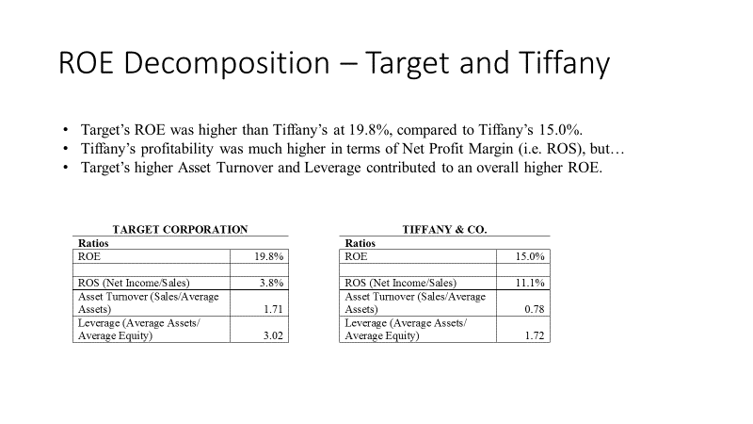

**OR**

|  |  |
| --- | --- |
|  |  |

*Example of Report using Target and Tiffany*

*Note: Return on Sales ROS is also known as Net Profit Margin.*

**ROE decomposition: Target Corporation and Tiffany & Co.**

For fiscal 2016, Target Corporation achieved a higher Return on Equity (ROE) than Tiffany & Co. As shown below, Target’s ROE was 19.8%, compared to Tiffany’s 15.0%.

Tiffany’s Return on Sales (ROS) was much higher than Target’s (11.1% versus 3.8%), in part reflecting Tiffany’s higher margin products.

Target’s Asset Turnover was higher than Tiffany’s (1.71x versus 0.78x), indicating that Target generates a greater amount of sales for each dollar invested in assets. This comparison is consistent with Target’s business as a higher volume discount retailer.

Target’s leverage was substantially higher than Tiffany’s (3.02 versus 1.72.) Over the past two years Target has repurchased over $7 billion shares, contributing to higher financial leverage. However, Target’s credit rating remains relatively strong: its long-term credit rating is A2 from Moody’s and A from Standard & Poor’s.

In summary, although Tiffany’s profitability was higher in terms of Net Profit Margin (i.e. ROS), Target’s higher Asset Turnover and Leverage contributed to its overall higher ROE.

**ROE Decomposition: Ratios**

|  |  |  |  |  |
| --- | --- | --- | --- | --- |
| **TARGET CORPORATION** | |  | **TIFFANY & CO.** | |
| ROE | 19.8% |  | ROE | 15.0% |
|  |  |  |  |  |
| ROS (Net Income/Sales) | 3.8% |  | ROS (Net Income/Sales) | 11.1% |
| Asset Turnover (Sales/Average Assets) | 1.71 |  | Asset Turnover (Sales/Average Assets) | 0.78 |
| Leverage (Average Assets/ Average Equity) | 3.02 |  | Leverage (Average Assets/ Average Equity) | 1.72 |

**Data**

|  |  |  |  |  |
| --- | --- | --- | --- | --- |
| TARGET CORPORATION | |  | TIFFANY & CO. | |
| *($ millions) year ended Jan. 28, 2017*  *Source: Target 10-K* | |  | *($ millions) year ended Jan. 31, 2017*  *Source: Tiffany’s 10-K* | |
|  |  |  |  |  |
| Net Income | $ 2,669 |  | Net Income | $ 446 |
| Sales | $ 69,495 |  | Sales | $ 4,002 |
| *Average Assets | $ 40,717 |  | *Average Assets | $ 5,110 |
| *Average Equity | $ 13,477 |  | *Average Equity | $ 2,979 |
| *Beginning Assets* | *$ 41,172* |  | *Beginning Assets* | *$ 5,122* |
| *Ending Assets* | *$ 40,262* |  | *Ending Assets* | *$ 5,098* |
| *Beginning Equity* | *$ 13,997* |  | *Beginning Equity* | *$ 2,930* |
| *Ending Equity* | *$ 12,957* |  | *Ending Equity* | *$ 3,028* |
| *\*Calculated* | |  | *\*Calculated* | |

1. Late assignments will be penalized 10 points.
2. Late assignments will be penalized 10 points.